Website Style Guidelines

Prepared by: Engineering Strategic Communications
Last update: May 2017

WordPress themes

Engineering Strategic Communications provides WordPress themes for official faculty websites. These themes have the following styles integrated into the templates and CSS files. If you are using a platform other than WordPress, please be sure to follow these guidelines for brand consistency.

Fonts

The only web font Engineering uses is the Google font Open Sans:
https://fonts.google.com/specimen/Open+Sans

Please only use this font. Different weights of Open Sans are used for variation.

Colour palette

Dark blue: #001a5c
Teal: #007393
White: #ffffff
Light grey: #d2d2d2
Dark grey: #333333
Black: #000000

Site Headings

Site headings should be dark blue (#001a5c) and mixed case. CSS as follows:

h1 {font-size:32px; color:#001a5c; font-weight:300; line-height:40px; letter-spacing:-1px;}
h2 {font-size:28px; font-weight:300;}
h3 {font-size:24px; font-weight:300; }
h4 {font-size:18px; font-weight:600;}
h5 {font-size:16px; font-weight:400;}
h6 {font-size:14px; font-weight:600;}

Paragraph text

p {font-size: 16px; color:#333333; font-weight:400; line-height:24px; }

Links

Text links should be teal colour (#007393), and on hover should switch to dark blue (#001a5c) with underline style.

CSS for hyperlinks:

a {color:#007393; text-decoration:none;}
a:focus, a:hover {color:#001a5c; text-decoration: underline;}

Header

Left-aligned elements:
- logo/signature (must be blue version, not black; links to FASE website)
- name of site
- primary navigation
- global navigation (if applicable)

Right-aligned elements:
- search form
- secondary menu
- social media icons (if applicable)

Navigation

Primary navigation should run horizontally along the top of the page, under the site title and logo. Menu items should be mixed-case. Please do not upper-case menu items.

Menu items should be 15px, font-weight: 600, and dark blue (#001a5c).

Drop-down menus (displayed on hover or click) should be formatted as:
font-size: 14px; font-weight: 400; line-height: 18px; color: #333333; background-color: #ffffff

Drop-down menu items should be separated by a 1px dotted border on top and bottom.

Sample:

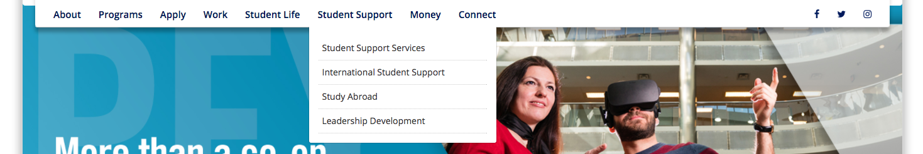

Footer

Footer content must be wrapped in dark blue (#001a5c) container. Text must be white (#ffffff). Elements should include:
- applicable menu items, including Contact link
- signature/logo (must be white version)
- street address
- link to FASE website: engineering.utoronto.ca
- link to utoronto.ca

Homepage elements

Hero

The hero section is displayed under the primary navigation. It is a visual element that stretches the width of the template and highlights featured content. It has a text component overlaid on the image, as well as a link that drives to a specific page on the site. Sample:

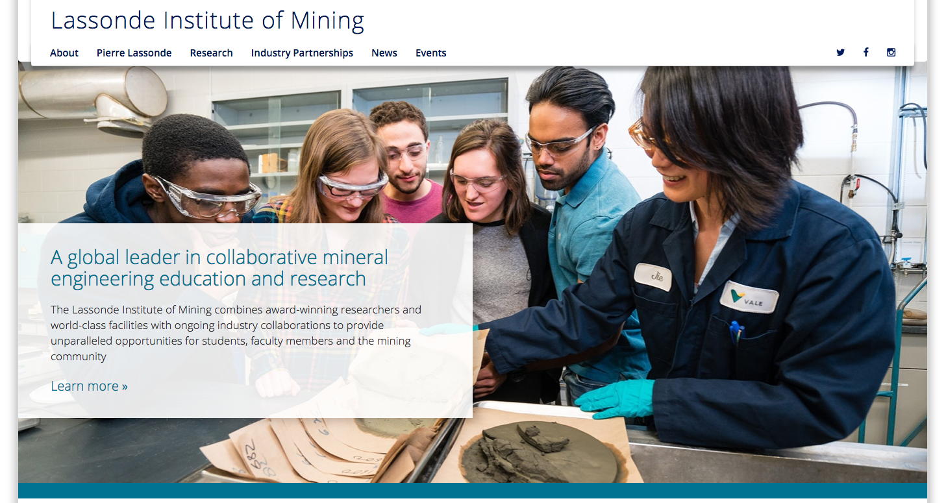

Follow us

The “Follow Us” section lists the social media channels. Sample:
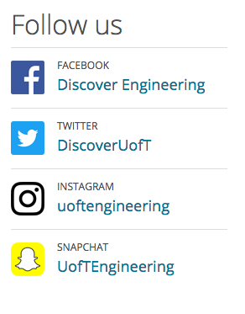

News

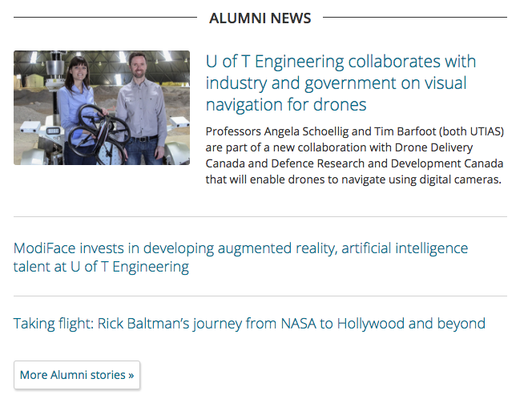

Events

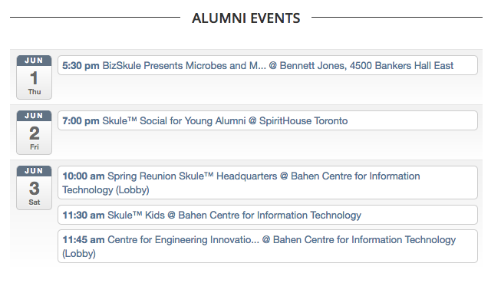

Quick Links

Call-out section

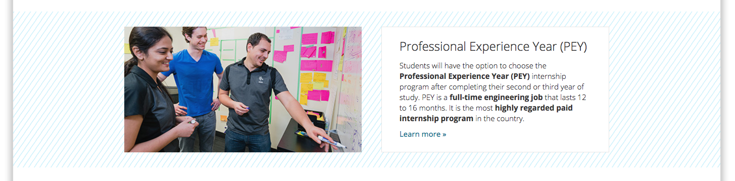

Interior pages

Page layout options: full width (one column), left sidebar (2 columns), right sidebar (2 columns), left & right sidebars (3 columns)

Left sidebar should be used to display navigational elements, such as a contextual navigation menu.

Right sidebar should be used for additional content that may be related to primary page content, i.e. links to other pages the users might find useful.

Use breadcrumbs below the navigation to help visitors understand where they are on the site.

Images

Images that are not used for decorative purposes must include alt tags and captions.

Images should contain very little or no text. This is for accessibility purposes – screen readers cannot read text that is embedded into images. It is also poor SEO practice.

Images should be optimized for web.

Imagery should reflect the Engineering and U of T brand. Contact us if you have any questions about what images to use on your website.

Icons

Icons used for social media, for example, should be minimalistic in design. Use official icons provided by social channels. Use Font Awesome for icons where applicable.

Questions?

Contact Roberta Baker, Web & Digital Communications Strategist.

